Task 4: Career Analyst – Audit

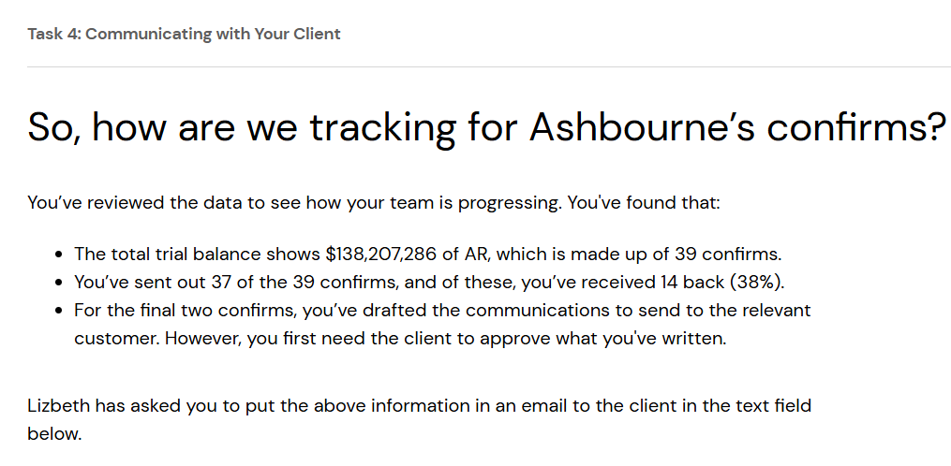

Dear [Client's Name],
I hope this message finds you well. I’m reaching out to provide an update on the confirmation process for Ashbourne Industries, Inc. as part of our audit procedures.
We have identified a total accounts receivable balance of $138,207,286 in the trial balance, which consists of 39 confirmations. To date, we have sent out 37 of these confirmations and have received 14 responses back, representing a response rate of 38%.
For the remaining two confirmations, we have prepared the necessary communications; however, we require your approval before sending them to the respective parties. Please let us know if you approve of proceeding with these confirmations, or if there are any adjustments you’d like us to make.
Thank you for your guidance, and please don’t hesitate to reach out with any questions.
Best regards,
Shaghayegh Haghbin

